Iteration 0

**Team roles:**

* Scrum Master: Catherine Shen
* Product Owner: Benjamin Hawn
* Team Member: Liuyi Jin
* Team Member: Bhogesh Maddirala

**Github repo:** <https://github.com/bhawn/CSCE_606_Project>

**Pivotal Tracker:** <https://www.pivotaltracker.com/n/projects/2536278>

**Summary:**

* Our customer, Dr. Walker, on behalf of Texas A&M’s CVMBS[1] PEER[2] program, informed our team that the goal of our project would be to implement a single javascript based education game about vaccines, COVID-19 in particular, in order to raise awareness.
* Although the goal of our project is in creating a vaccine based educational game, our team was instructed to focus our efforts on making the game fun rather than going into details of how the vaccine works; that is for our main focus to be on the game with a theme around vaccines so that students will enjoy playing it while still gaining an understanding of the benefits that being vaccinated against covid brings you. On the technical side of things, we were informed that we need to use javascript or a javascript framework to implement the aforementioned game on a wordpress website. The details were left to us for this step however we were informed that we need to make sure that the game should work in all environments including mobile.

**User Stories:**

* **Note**: As the goal for the game itself has not yet been decided upon (beyond the theme of vaccinations), we have provided a few more generalized user stories, as well as some examples of what such a game could look like in the UI mockups.

1. Feature: Implement an enjoyable educational game/game page

As a student/player,

I want to enjoy playing the vaccine awareness game,

So that I learn while not not feeling like its a chore

1. Feature: Implement information on where to find the vaccines

As a student/player,

I want to know where you can get vaccinated

So that I can get the vaccine now that I am informed

1. Feature: Implement page to get more information on vaccines

As a student/player,

I want to know where to find more information on vaccines

So that I can be more informed

1. Feature: Implement page for game instructions

As a student/player

I need instructions

So that I know how to play the game

**User Interface:**

* Storyboard of entire game -

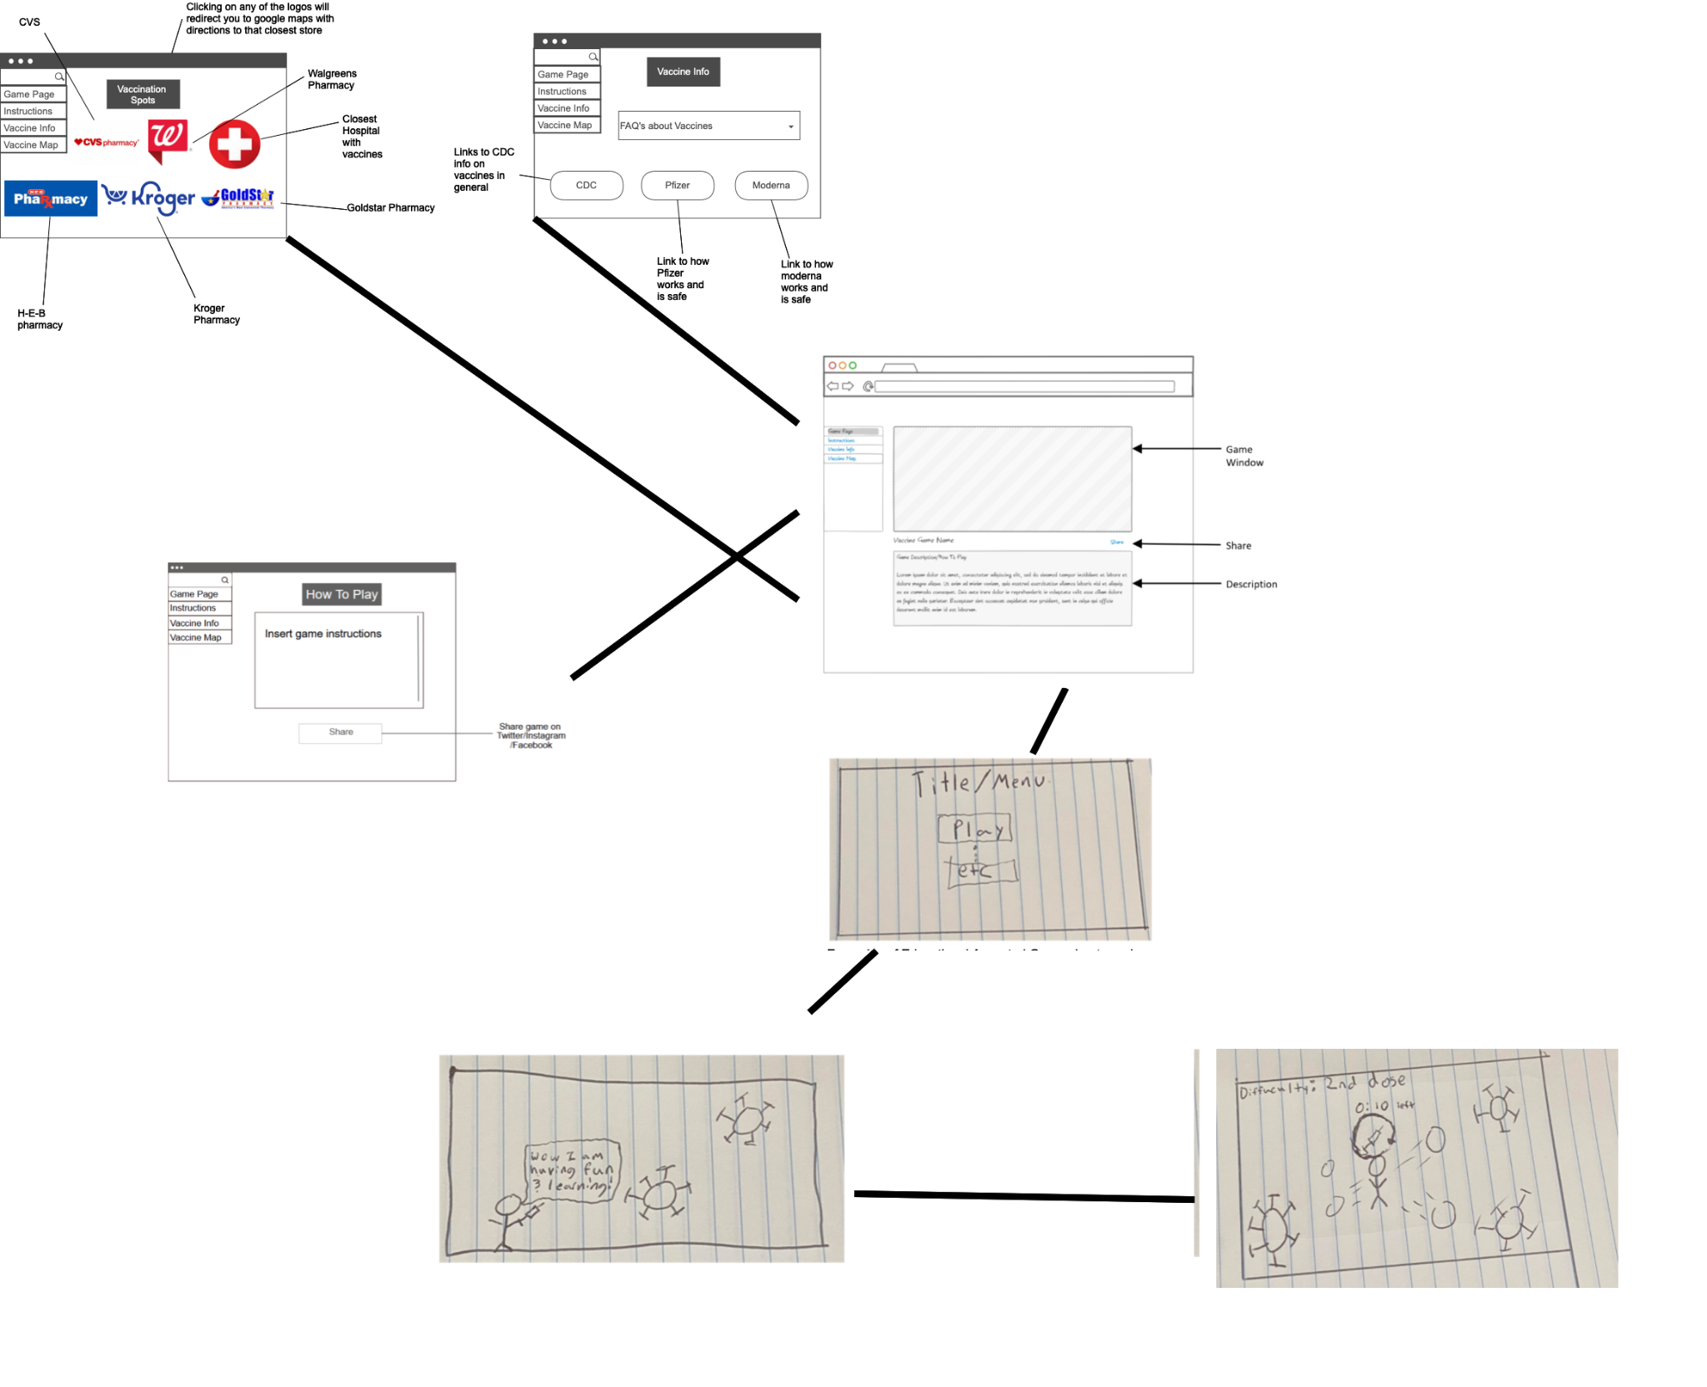

* Game Page (User Story #1) -

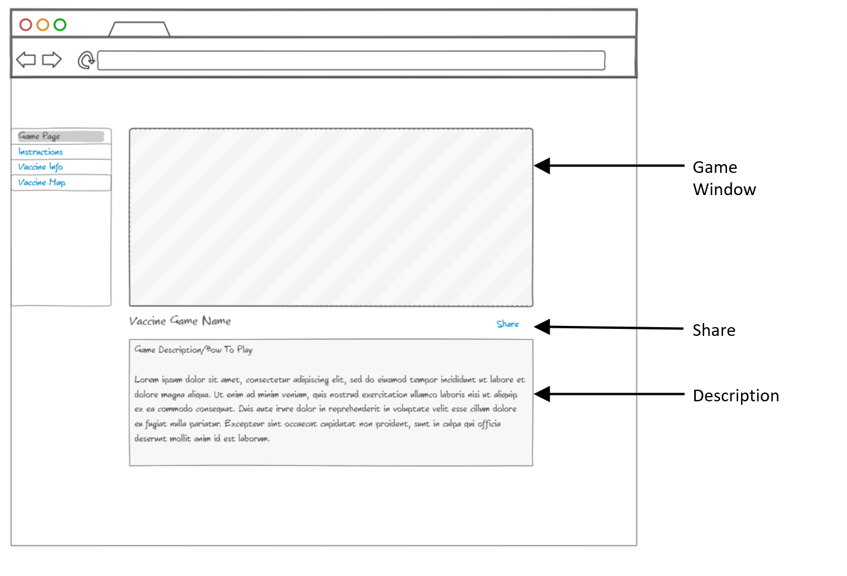

* + On Game load, there will be some form of Menu/Title Screen to interact with

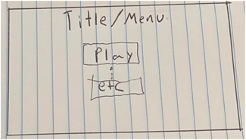

* + Examples of Educational Aspected Game about vaccines

|  |  |
| --- | --- |

* Vaccine Map page (User Story #2) -

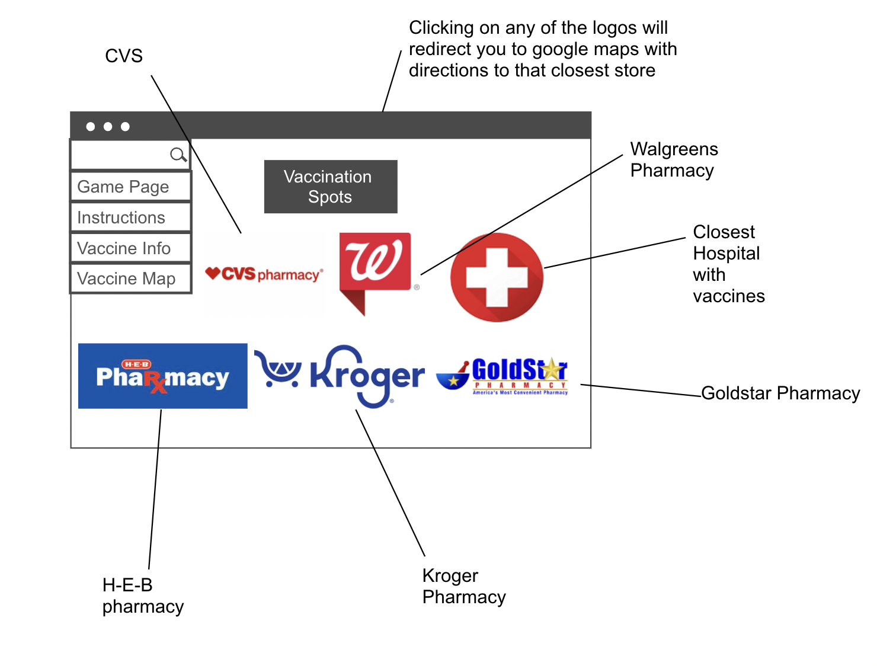

* Vaccine Info Page (User Story #3) - 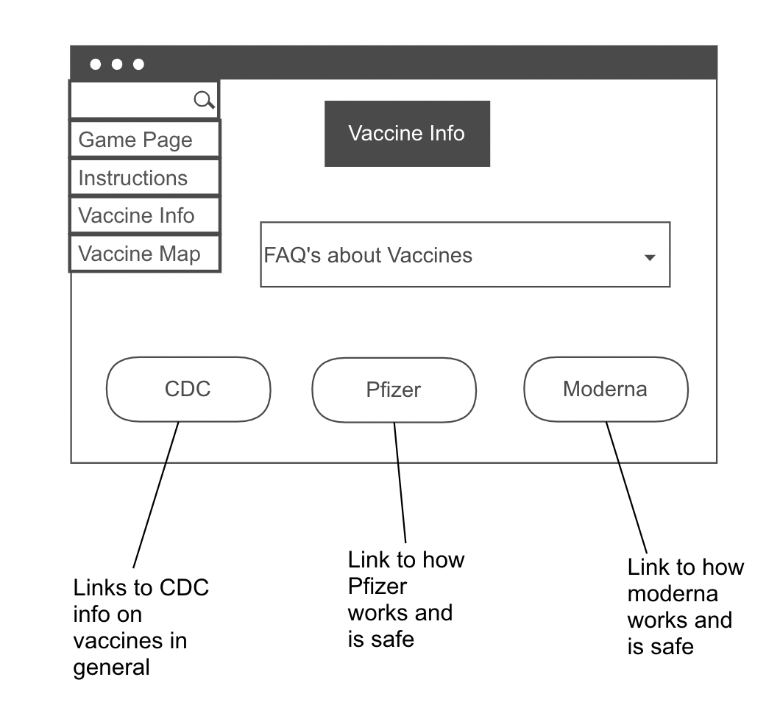
* Game Instructions Page (User Story #4) -

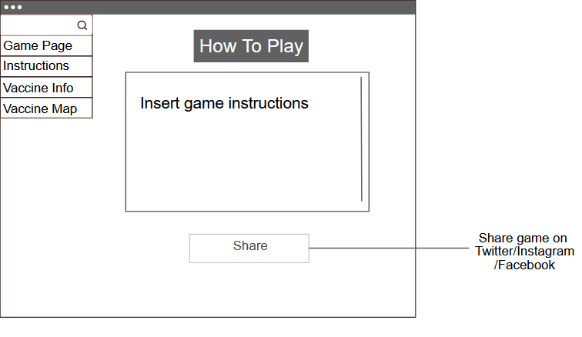

1. College of Veterinary Medicine & Biomedical Sciences
2. Partnership for Environmental Education & Rural Health